Student Parking Account - Step by Step

To Create or Log in to your account go to <https://gloscolcheltapp.zatpermit.com>

You will need your student email address to create an account

Student [number@student.gloscol.ac.uk](mailto:number@student.gloscol.ac.uk)

(i.e 123456@student.gloscol.ac.uk)

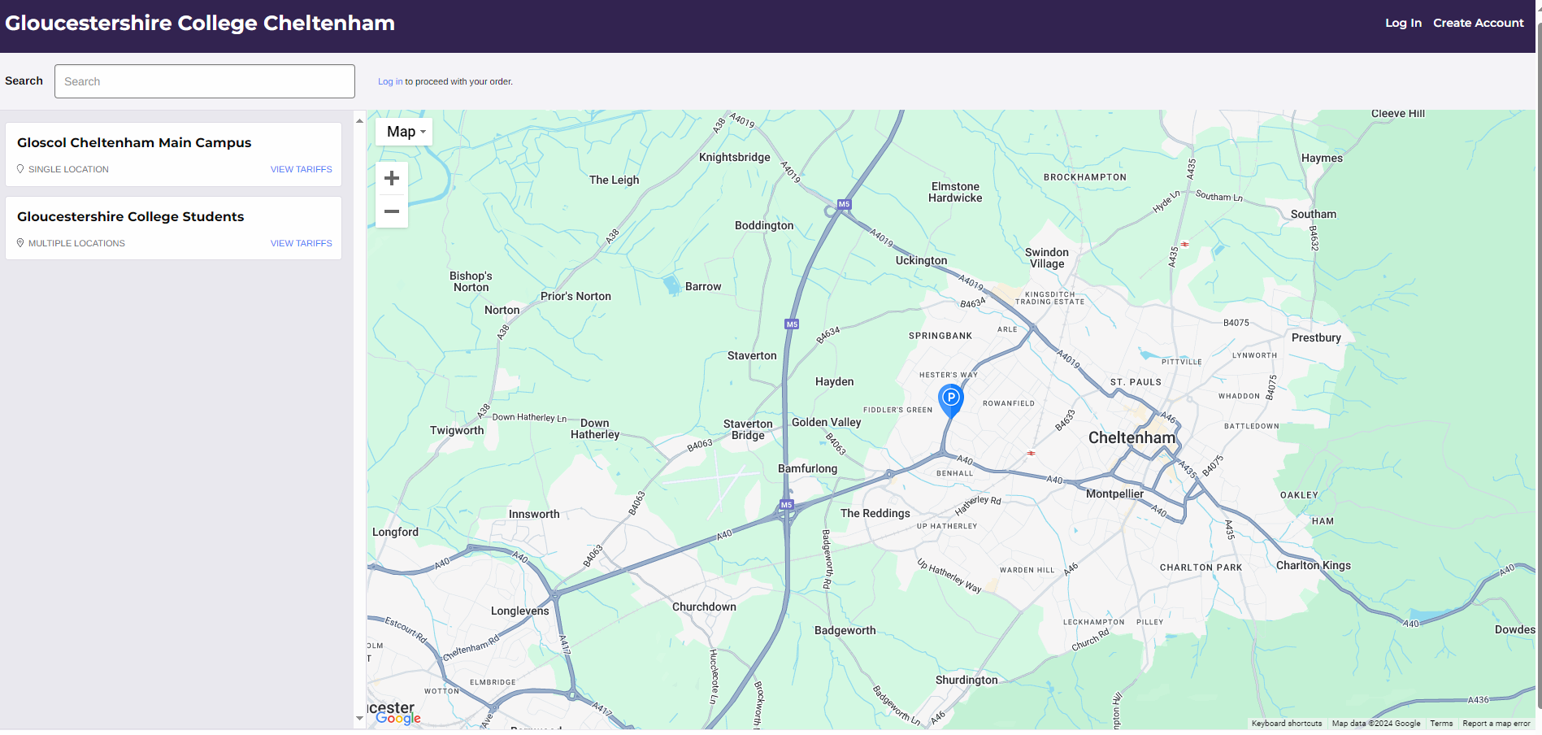

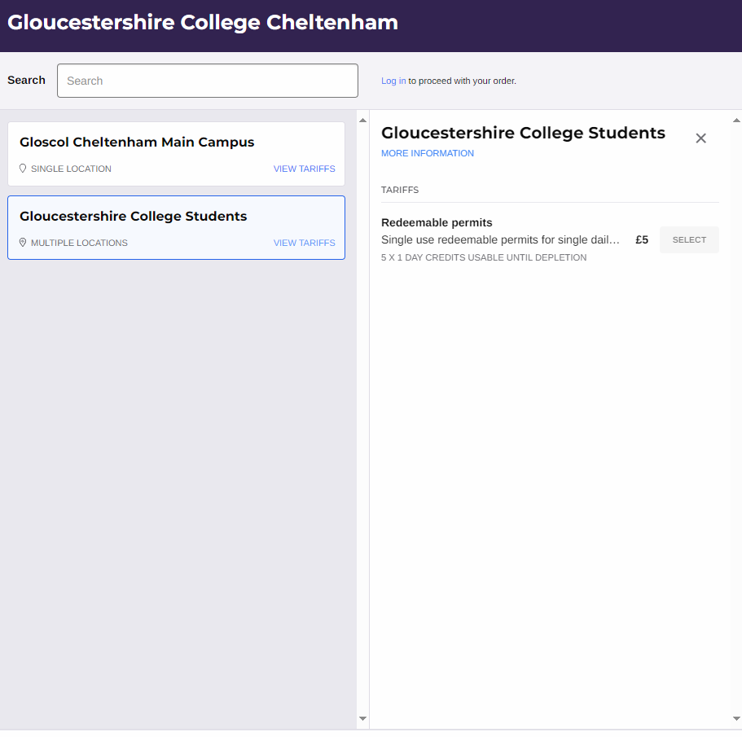

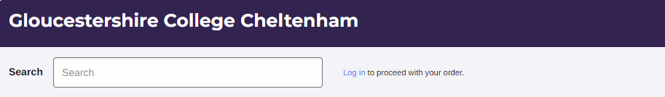

Purchasing permits requires the following:

You will need to upload a form of identification to prove that you are a current student

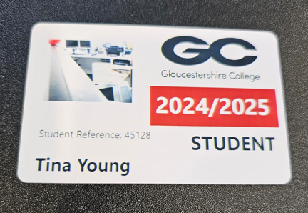

Your student ID or Your letter of enrolment with your student ID number on will be accepted

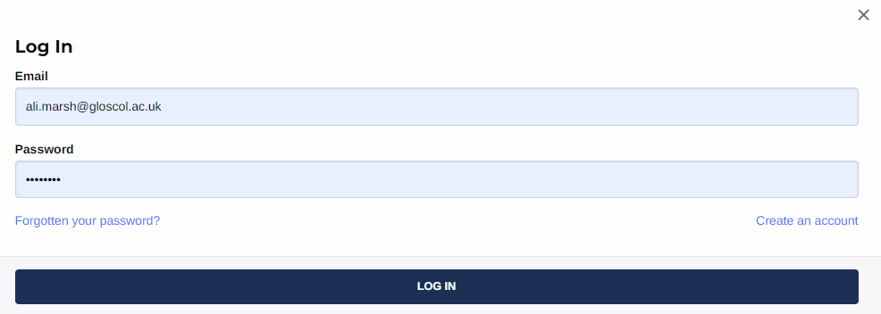

Redeemable Permits are sold in batches of 5, they are valid until they are depleted

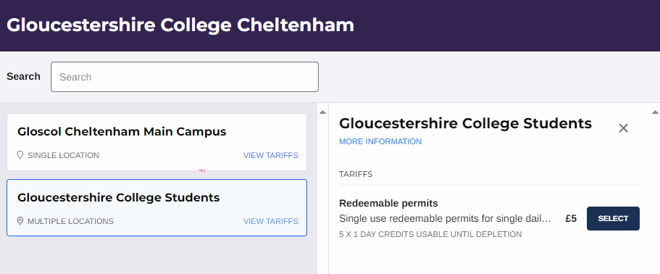

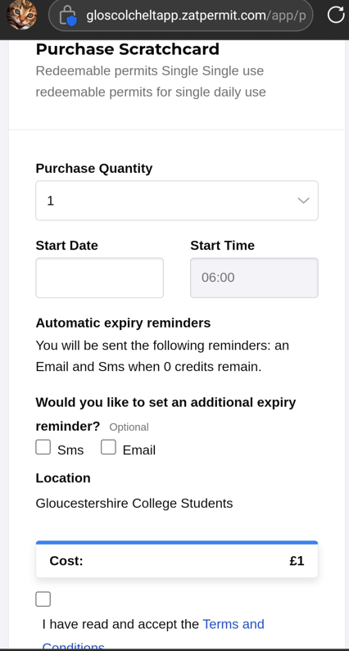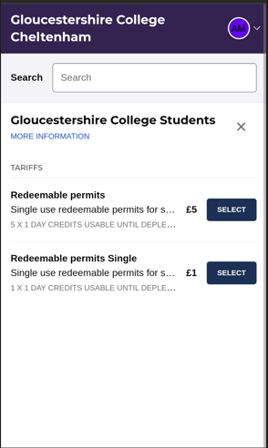

**Redeemable Permits are available in booklets**

**or as a one-day permit**

**If you purchase batches in advance; don’t forget to activate your permit against the correct car registration on arrival into**

**the college car park**

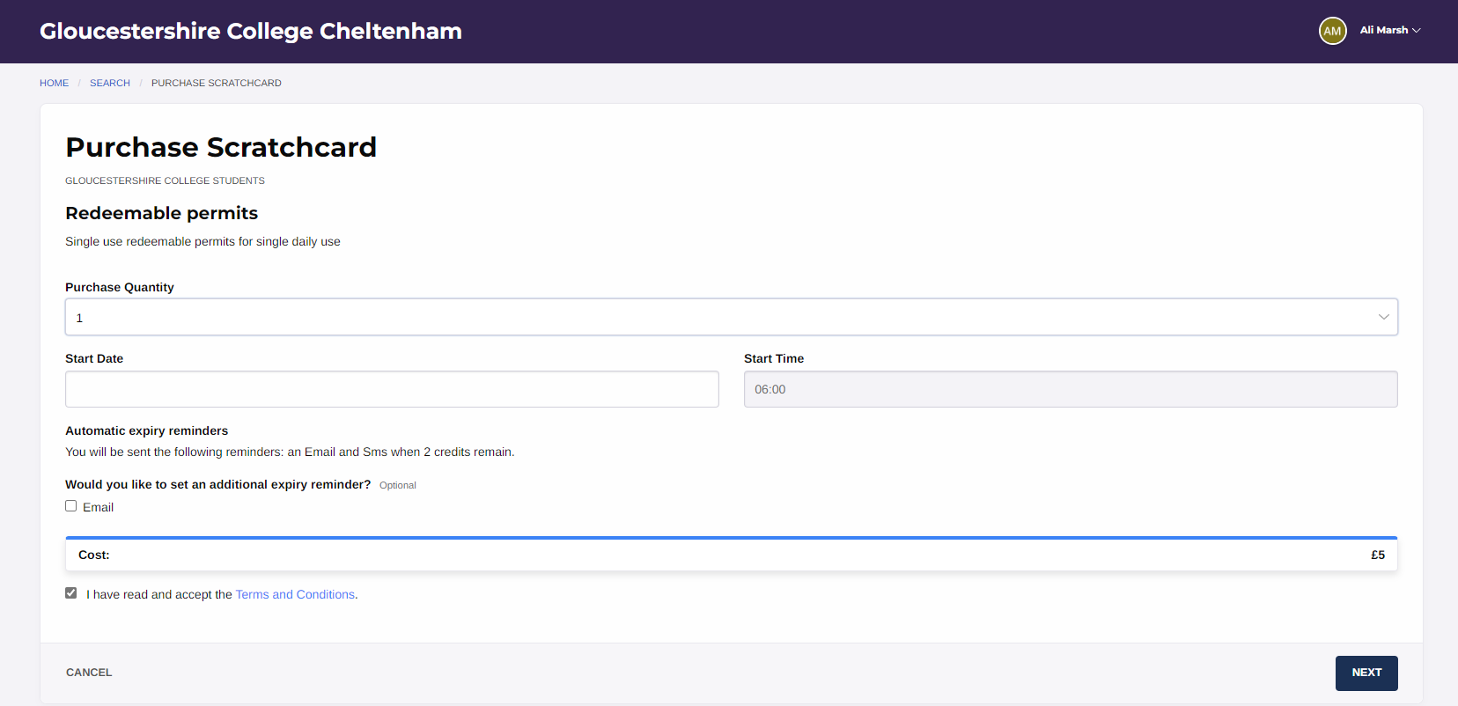

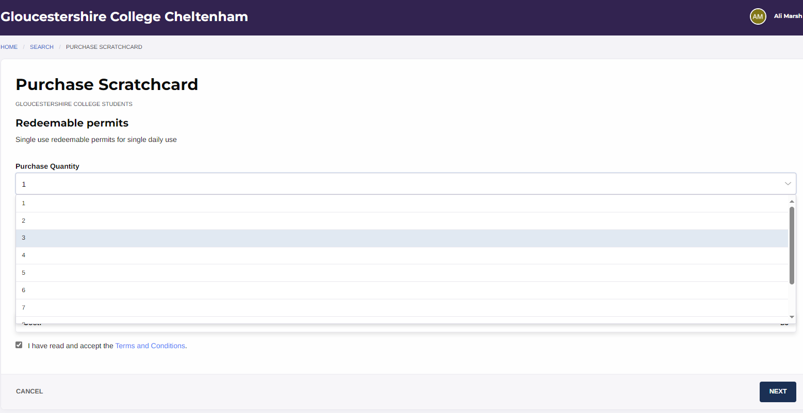

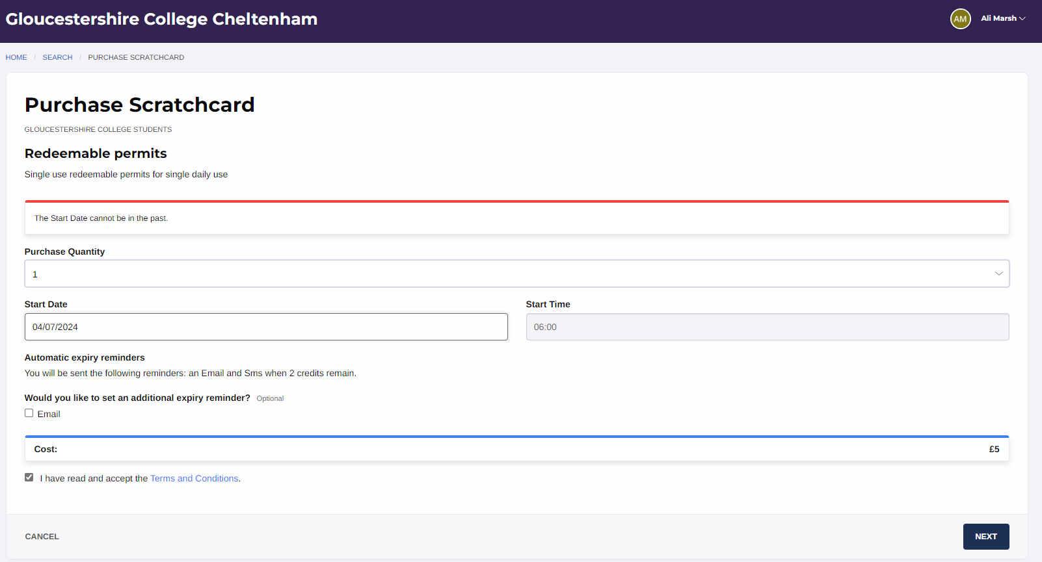

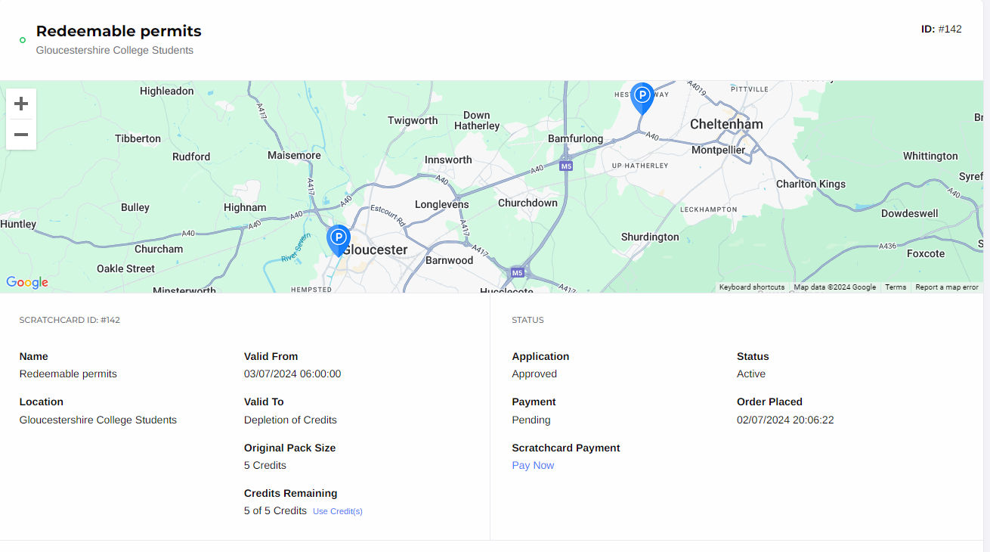

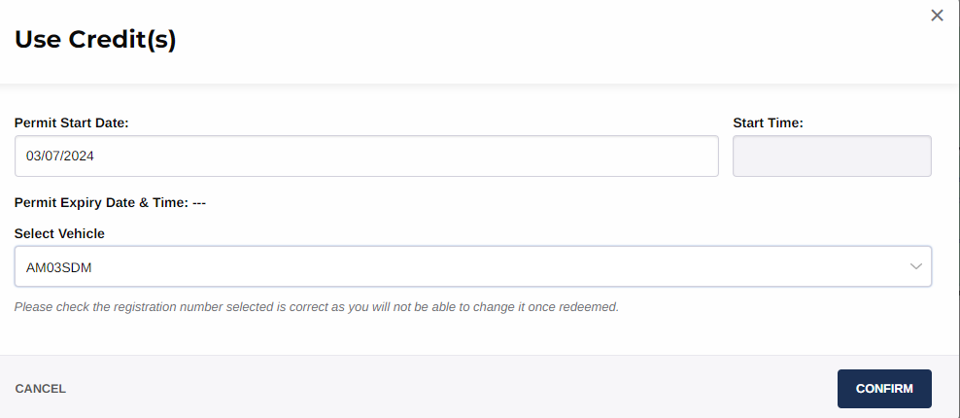

Important Information

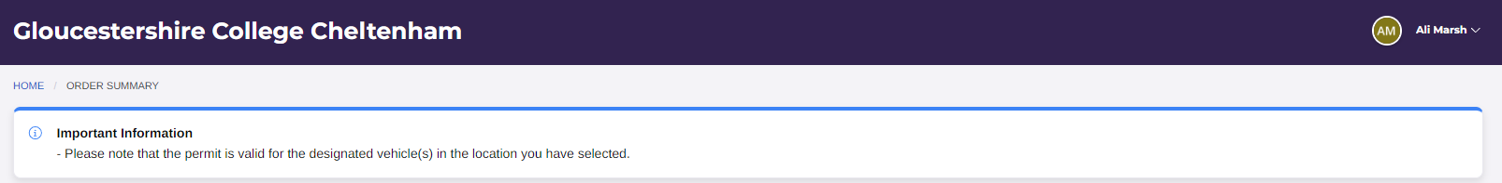

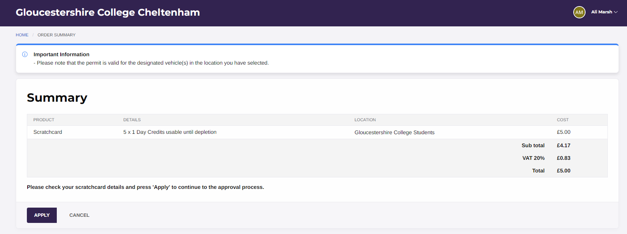

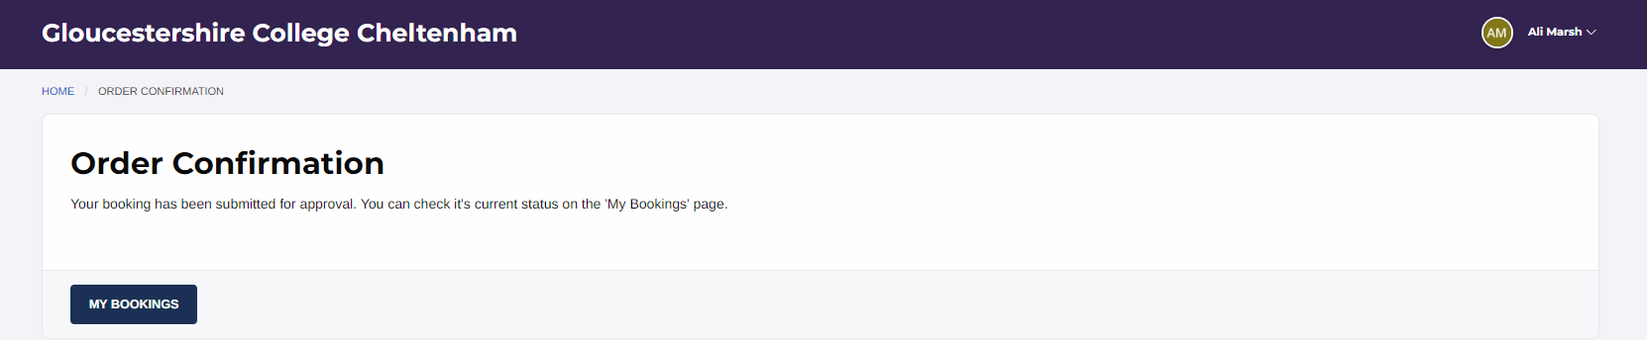

How to manage your account

